How to Default Outlook Font to Arial, size 11
This SOP will outline how to set the default Outlook font to Arial, size 11 for both classic and new versions
For Classic Outlook users
- Launch the Outlook application and navigate to the File tab

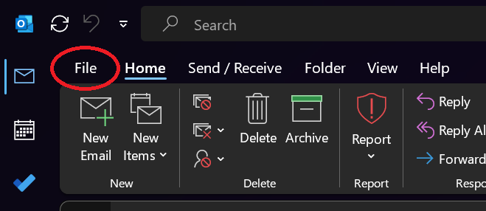

- Navigate to the bottom of the screen and click on Options

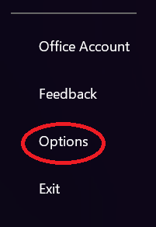

- Navigate to Mail and under the Compose Messages section, click on the Stationery and Fonts setting

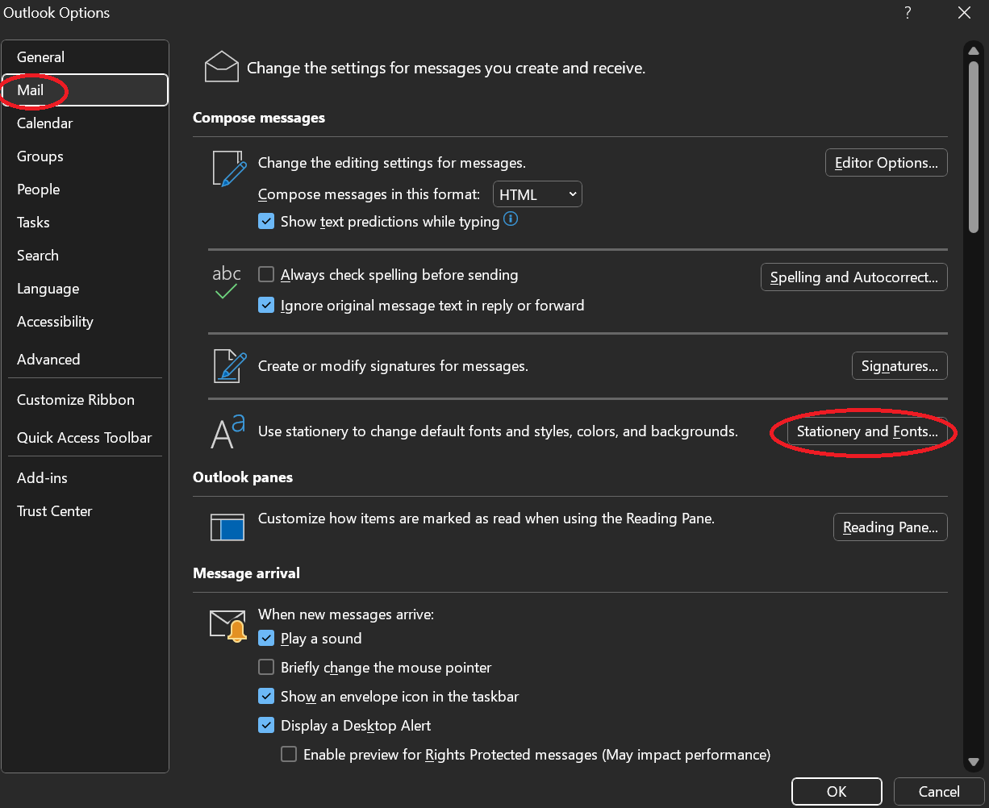

- From this page you will be able to set the default font/font size for all new mail messages and forwards to Arial
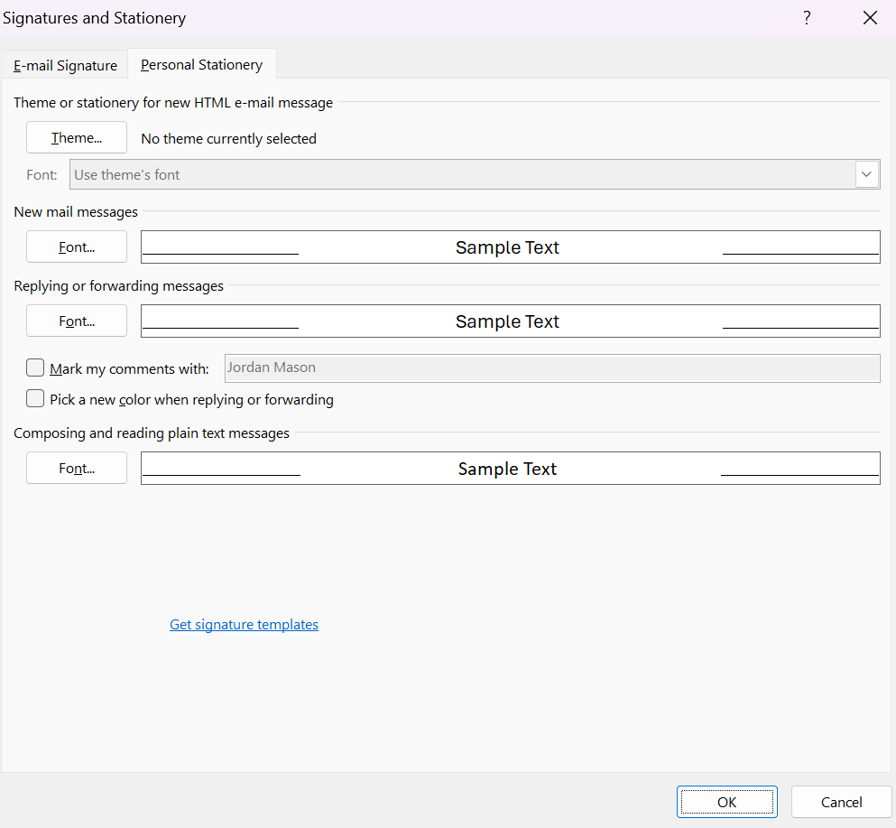

For New Outlook users

- Launch the Outlook application and navigate to the gear shaped icon at the top left-hand corner

- From the settings page, click Mail and hover to the Compose and reply tab. From this tab you will be able to set the default font/font size to Arial, size 11

